BLY 111: GENERAL BIOLOGY
TOPIC: ECOLOGY, HABITATS AND DIVERSITY
By
Akwashiki Ombugadu
Department of Zoology, Faculty of Science, Federal University of Lafia

Learning objectives
By the end of this lecture, students should be able to:
- Define ecology.
- State the broad objectives, divisions and basic rules of ecology.
- Describe the ecosystem, habitats and species diversity.
INTRODUCTION
Ecology (“oekologie” in greek) comes from two greek words: Originally “Oikos”- meaning household, home and place to live, and “Logos” means - discourse or study of the habitation of an organism. Ecology is a science that studies relationships between living organisms and the environment they live in. Similarly, it is also defined as the relation of the animal to its organic as well as inorganic environment. The environment includes the immediate surroundings to the plant or animals.
A British ecologist “MacFadyen” said ecology concerns itself with the interrelationships of living organisms, plants or animals and their environment. These are studied with a view to discovering the principles which govern the relationships.
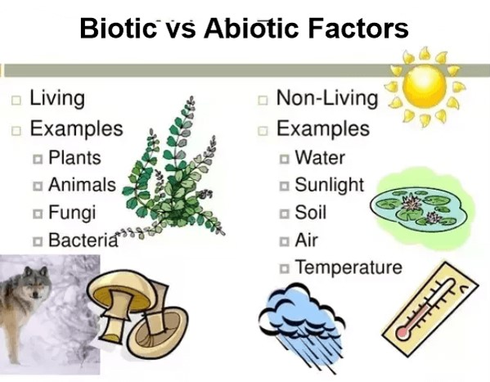
The major goal of ecology is to understand how these diverse interactions influence the geographical distributions and abundance of plant and animal populations.
Broad Objectives of Ecology
- To determine the local and geographic distribution and abundance of organisms.
- To examine temporal changes in occurrence and abundance.
- To determine the interrelationships between organisms and population, community, inter-specific and intra- specific competition.
- To gain an understanding of the structural adaptations and functional adjustments of organisms to their physical environment.
- To gain an understanding of the behavior of organisms under natural conditions.
- To understand the evolutionary development of the interrelationships.
- To understand the biological productivity of nature and how it may be applied to man.
- It helps us develop mathematical models to relate interactions and predict outcome.

The importance of ecology
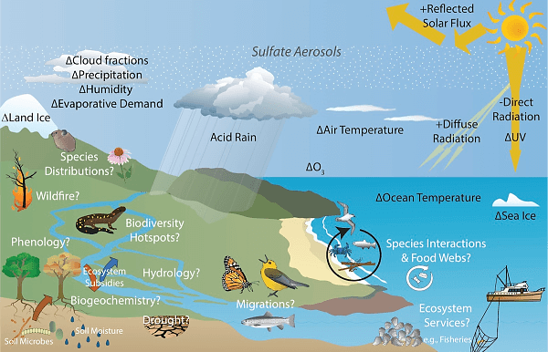

In the course of ecological studies some Endemic Bird Species in Nigeria were found as shown below:
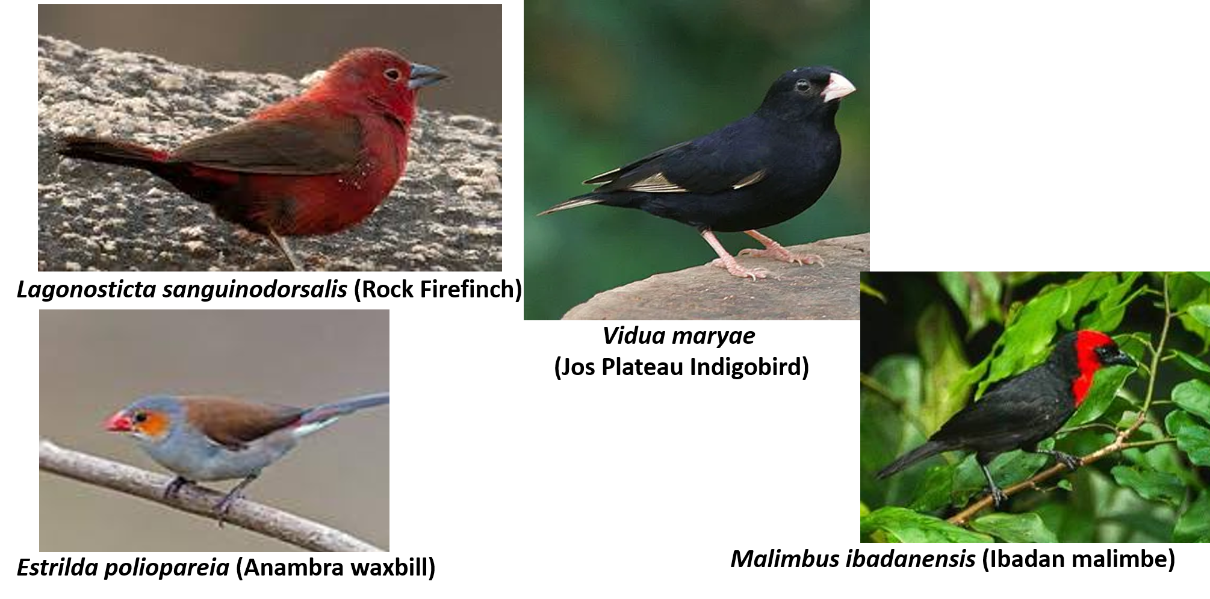
Divisions of Ecology
- Animal ecology - deals with heterotrophs
- Plant ecology - deals with autotrophs
- Bioecology - emphasizes plants and animals together
- Autecology - a study of a particular species and its ecology or relationship of an organism to its environment
- Synecology - study of more than one species i.e. a community
- Evolutionary ecology - this deals with niche separation and processes of segregation. Niche is the functional role of an organism in the ecosystem
- Geographic ecology - concerned primarily with distribution
- Paleoecology - based primarily on past distribution (fossil record)
- Physiological ecology - describes how organisms respond and adjust physiologically to the physical factors of the environment
- Systems ecology - deals with translating ecological concepts into mathematical models used for prediction
- Human ecology - man’s relationship to the environment and implication of man’s effect.

Basic Rules of Ecology
Actually no truly precise principles exist and should not be a dogma or law.
- The ecosystem is the major ecological unit containing both biotic and abiotic components through which nutrients are cycled and energy flows.
- For effective cycles and flows; the ecosystem must contain a number of structured interrelationships among its components (soil, water, nutrients, producers, consumers, decomposers).
- The functional ecosystem is related to flows of energy and cycling of nutrients among components.
- The total amount of energy flowing depends largely on the amount fixed by plants (producers), while a considerable portion is often loss in course of transition. Therefore, limiting the number of organisms at each feeding level.
- The ecosystem tends towards maturity i.e. passes from less complex to a more complex state by succession.
- When the ecosystem is exploited and such is maintained, the maturity of the ecosystem declines.
- The major functional unit of the ecosystem is the population. It occupies a specific niche in the system and plays a particular role in energy flow and nutrient cycling.

THE ECOSYSTEM
The ecosystem is an open system that receives energy from an outside source (the sun), fixes and utilizes it and ultimately dissipates heat to space.
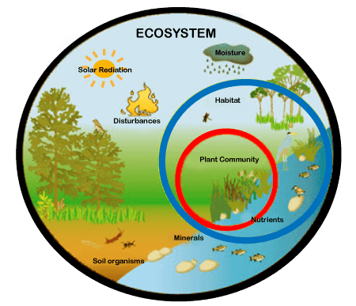
The ecosystem is composed of and defined by:
Biosphere- This is the blanket of life surrounding the earth, it is the largest ecosystem.
Lithosphere- Outer shell of the earth’s crust which supports life, foundation for organism, provides the materials from which organisms are made- primary source of nutrients.
Hydrosphere- This is the body of liquid on or near the surface of the earth.
The ecosystem consists of all populations in an ecological community together with their physical environments. The key processes are (i) flow of energy and (ii) cycling of materials. The incorporation of energy and materials in an ecosystem required to construct life is called “productivity” which is divided into components, trophic levels.
The trophic levels are linked together into “food chains” a linear feeding relationship that shows what eats what. This connotes the movement of energy from plant compounds to organisms that eat plants, then to other organisms that eat the plant feeders, further through a linear series of organisms that feed and then eaten by others eg:-
Green grass→Grasshopper→Toad→Snake→Hawk→Decomposers (Bacteria/Fungi).
Food web-This is a complex feeding relationship of species in an ecological community according to how they acquire nutrition; producers, primary consumers (herbivores and carnivores).
Primary producers- are organisms that produce by fixing and storing energy from outside the ecosystem, usually green plants that convert CO₂ (carbon dioxide) and H₂O (water) and radiant/solar energy by photosynthesis.
Consumers- include herbivores that eat plants directly and carnivores which eat other animals.
Decomposers – they are mainly fungi and bacteria which break down dead organic matter into its mineral components returning it into soluble form for plant use.
Energy Flow- Living things/organisms need energy to grow, move, reproduce, excrete etc. in other words energy is needed for life. Autotrophs obtain their energy by photosynthesis while heterotrophs take in organic compounds by feeding on autotrophs. In summary;
-sun energy
-green plants/ chemosynthetic organisms
-production of chemical energy (ATP, NADPH, Glucose)
-physiological functions such as; contraction of muscles, transport and biosynthesis. Dissipated energy lost from biological systems is called ‘heat entropy’.
Gross productivity- This is total energy assimilated, serves the animal’s metabolic demands, cellular metabolism and regulation of body heat in endotherms.
Net productivity- This is the energy stored by an animal in its tissues as biomass. Animals use some of this energy for growth and reproduction.
The first law of thermodynamics explains that energy is available for growth of individuals and populations only after performing maintenance P_{n} = P_{g} – R
The second law states every energy transformation involves a loss of useable energy as energy passes from green plants to primary consumers, then secondary consumers and lastly decomposers. The total disorder or randomness of a system always increases. Energy for maintenance ‘R’ usually constitutes more than 90% of the assimilated energy (Pg) for animal consumers. More than 90% of the energy in an animal’s food is lost as heat and less than 10% stored as biomass. Therefore, each succeeding trophic level contains less than 10% of the energy in the next lower trophic level. Most ecosystems are thereby limited to five or fewer trophic levels.
Pyramid of Numbers:-
This is the graphical representation of the numbers of individuals in each population in a food chain, thus;

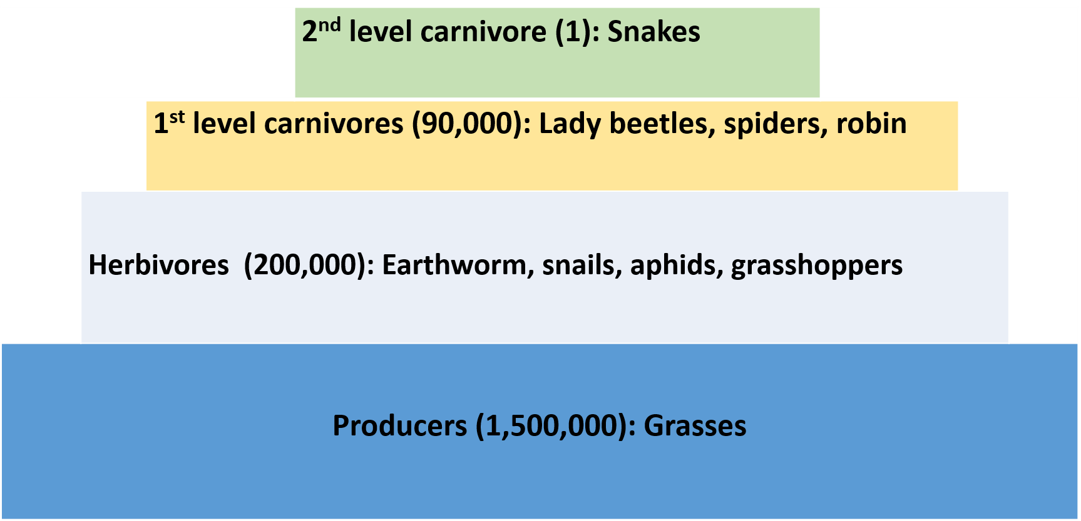
Pyramid of Biomass:-
This is the census of the population multiplied by the weight of an average individual in it i.e. an estimated weight of the population.
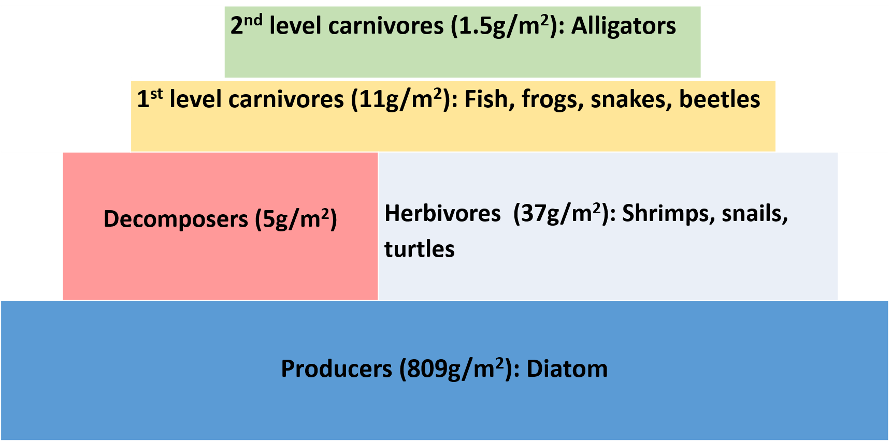
Pyramid of Energy:-
This is the decrease in the total available energy at each higher trophic level
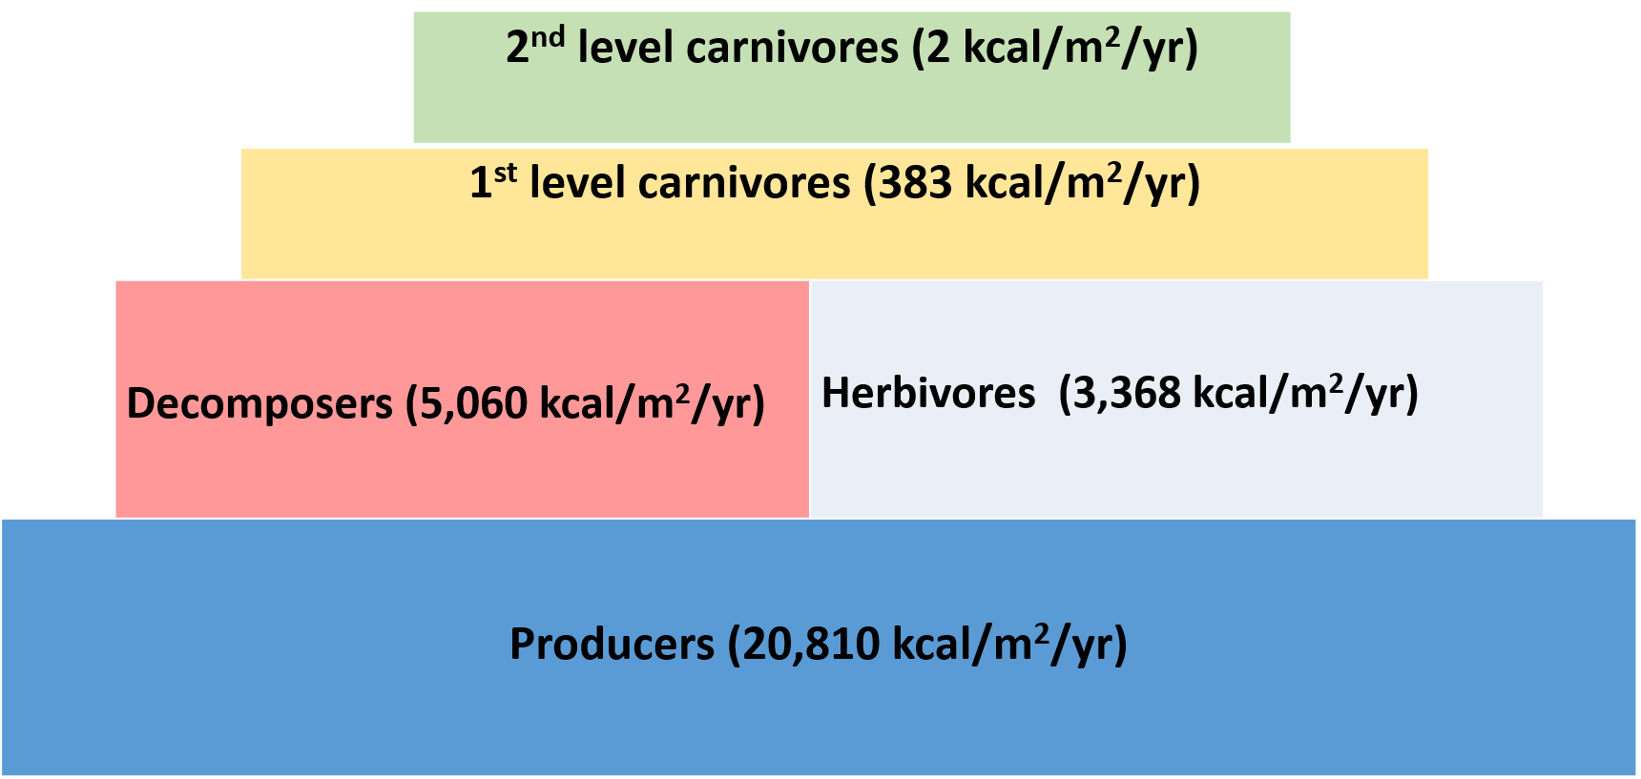
HABITAT
Habitats are the places plants and animals normally live. The crocodile’s habitat is water especially rocky pools or river systems. The rotten wood is a normal habitat for carpenter ants. The logs occur in larger forest; deer also inhabits a forest and open vegetation while migratory birds occupy forest during winter. Thus a habitat is defined by an animal’s normal activity rather than by arbitrary physical boundaries. Some important habitats are forest, grasslands, deserts and marshes. Obviously, the concept of “niche” focusing more on the animal’s job while “habitat” focuses more on what corner of nature the organism occupies.
NICHE
This is the role and position of a species in nature. Someone defines it as ‘what it eats and what eats it’. Another way of looking at it is that a niche is basically an organism’s job in nature. In the average school of thought, it’s okay to say that the niche of the fish swimming in a fresh water lake, where it mostly eats mosquito larvae and serves as the main food source of fish larger than it, such as bass.
Essentially, an organism’s niche is also defined by how it makes a living; it’s role in the community, the environmental conditions it tolerates, the important resources it needs to survive and its ways of obtaining those resources. Therefore, an organism’s niche touches upon its habitat, the resources it needs and its behavior.
POPULATION
This is defined as a group of organisms of the same species inhabiting a specific geographical locality at a particular time.
COMMUNITY
This is an assemblage of species that are associated in a common area and interact with one another in a self sustaining and self regulating relationship. Different organisms are found in different places. There are only a few basic types of communities or biomes on earth which extend over large land mass.
Species Diversity
Species diversity is defined on the basis of two factors, the number of species in the community which is called species richness (number of species in a given or defined unit) and the relative abundance of species or species evenness. A community with 20 species is obviously less diverse than one with 80 species. The effects of species evenness on diversity are more subtle. Therefore species diversity depends upon levels of species richness and evenness.
Richness and Evenness
Richness is the number of species per sample is a measure of richness. Evenness is a measure of the relative abundance of different species, example we might have sampled two different fields for wildflowers. The sample from the first field consists of 300 Celosia argentia, 335 Magnifera indica and 365 Striga. The sample from the second field comprises 20 Celosia argentia, 49 Magnifera indica and 931 Striga, the sample has the same richness (3 species) and same number of individual (1000). However, the first sample has more evenness than the second because the number of individual species is not evenly distributed.
A commonly applied measure of species diversity is the Shannon-Wiener index
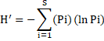

Where pi is the proportion of individuals found in the ith species and ln is the natural logarithm of Pi.
The maximum diversity (Hmax) of a sample is found when all species are equally abundant. Hmax = ln S, where S is the total number of species.
We can compare the actual diversity value to the maximum possible diversity by using a measure called evenness. The evenness of the sample is obtained from the formula:
Evenness = H'/Hmax = H'/lnS.

Example: A worked example from a community containing 100 trees distributed among 5 species using Shannon-Wiener index to ascertain the diversity status of the area.
Species | Abundance | Pi | ln(Pi) | Pi[ln(Pi)]
A | 50 | 0.5 | -0.69315 | -0.34657
B | 30 | 0.3 | -1.20397 | -0.36119
C | 10 | 0.1 | -2.30259 | -0.23026
D | 9 | 0.09 | -2.40795 | -0.21672
E | 1 | 0.01 | -4.60517 | -0.04605
Total | 100 |  |  | -1.2007
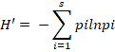 | H' = -(-1.207)
 | H' = +1.207

Also, Simpson's Index can also be used in measuring species diversity
- Simpson's Index gives the probability of any two individuals drawn at random from an infinitely large community belonging to different species. The bias corrected form of Simpson's Index is:
- The value of D ranges from 0 and 1, with this index, 0 represents infinite diversity and 1, is no diversity i.e. the bigger the value of D, the lower the diversity.

D = 1 - 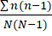
Where:
- n = number of individuals of each species
- N = total number of individuals of all species
Example: A worked example for 201 trees of 5 species assessed in several quadrats using Simpson’s diversity index to ascertain the diversity status of the area.
Species | No. of individuals (n)
A | 100
B | 50
C | 30
D | 20
E | 1
 | 201

Solution
The following solution will steps explain how to solve the problem by hand.
Step 1: Calculate n(n-1)
- Subtract 1 from each individual count (see the third column in the table below).
- Take each answer from (i) and multiply by each n (see the fourth column).
- Add up all the values from (ii) to get 13,600.
Species | No. of individuals (n) | n-1 | n(n-1)
A | 100 | 99 | 9900
B | 50 | 49 | 2450
C | 30 | 29 | 870
D | 20 | 19 | 380
E | 1 | 0 | 0
 |  |  | 13,600

Step 2: Insert the total number in the set (201) into the formula N(N-1) and solve:
N(N-1) = 201(201-1)
= 201(200)
= 40,200
Step 3: Calculate D
- Divide your answer in Step 1 by your answer in Step 2,
- Finally, subtract your answer from (i)
Therefore, D = 1 - 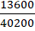
D = 1 - 0.338308
D = 0.661692

D ≈ 0.66
Note: Simpson’s diversity index cannot be negative. If it is, check your calculations for arithmetic errors.

